ASSIGNMENT 2

**Q1-**

**PEAS-**

**P**erformance measure: 2 points/win, 1 point/draw, 0 for loss

**E**nvironment: Chess board, pieces, rules, move history, opponent

**A**ctuators: move pieces, resign

**S**ensors: observe board position

Environment properties-

Observable: the agent can sense the entire state of the environment.

Deterministic: the outcome of actions is determined by the state of the board and the action executed.

Sequential: action outcomes can be affected by prior actions.

Static: state of the world doesn’t change during deliberation.

Discrete: actions can only be performed in a small fixed number of ways.

Multi-agent: there is the agent and the opponent.

**Q2-**

|  |  |  |  |  |
| --- | --- | --- | --- | --- |
| Agent |  |  |  |  |
|  |  |  |  |  |
|  |  | Lion |  |  |
|  |  |  |  | Home |

The agent can move up, down, left, right. The agent should move towards the home and stay within bounds.

If the agent detects heat in downward tile, it should move up, left, or right. If it detects heat in a tile to the right, it should move up, left, or down. Similar for other directions.

If the agent detects heat in two tiles, let’s say up and right, it should only move down or left. Similar for other directions. Only move in a way that takes it *away* from the heat and towards the home.

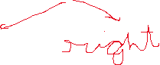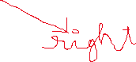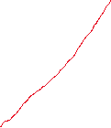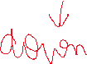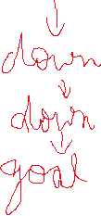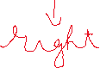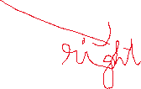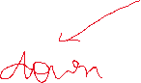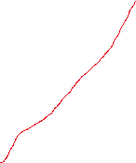

**Q3-**

Initial State: q = (M,C,B) signifying the number of missionaries, cannibals, and boats on the left

bank. The start state is (3,3,1).

Actions (successor function): (10 possible but only 5 available each move due to boat)

• One cannibal/missionary crossing L → R: subtract (0,1,1) or (1,0,1)

• Two cannibals/missionaries crossing L → R: subtract (0,2,1) or (2,0,1)

• One cannibal/missionary crossing R → L: add (1,0,1) or (0,1,1)

• Two cannibals/missionaries crossing R → L: add (2,0,1) or (0,2,1)

• One cannibal and one missionary crossing: add/subtract (1,1,1)

Goal state: The goal state is (0,0,0). Where all the missionaries and cannibals have crossed the river.



**Q4-**

